TELECOM CUSTOMER CHURN ANALYSIS
A Python (EDA) and SQL Analysis of Customer Churn Drivers
If You Want to See the Raw Python Eda File Click The Link Below
Python Raw Exploratory Data Anlysis File
Prepared by Debashis Sarkar
Dataset: IBM Telco Customer Churn | 7,032 records | 21 attributes
Overall churn rate: 26.58%

Business Problem
Customer churn is one of the most pressing challenges facing telecom companies, where high competition and low switching costs make retention directly tied to revenue. This report analyzes customer data from a telecom provider to uncover which factors — contract type, payment method, internet service, monthly charges, and tenure — are the key drivers of churn, and translates each finding into a specific, actionable recommendation for the retention and marketing teams.

Dataset & Cleaning Notes
The dataset contains 7,043 customer records with demographic, account, and service-subscription details. Total Charges had 11 blank values, all belonging to customers with 0 months tenure (new customers not yet billed). These 11 rows were dropped, leaving 7,032 customers for the analysis. Service add-on columns were kept in their original three-value form (Yes / No / No internet service) rather than flattened to binary, since "No internet service" represents a genuinely different customer type.

1. The Retention Cliff — Does churn risk change with tenure?
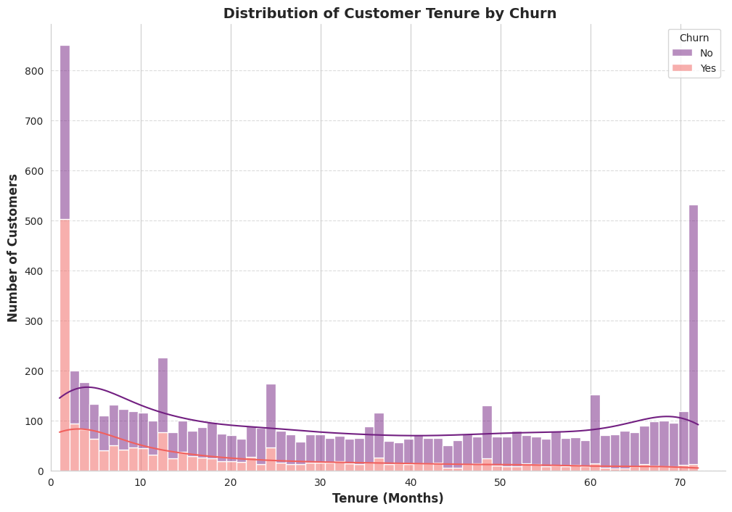
Finding: Churn is highest in the first 1–5 months of a customer's tenure, then drops sharply for customers who stay past 12 months.
Recommendation: Improve the onboarding experience and offer early check-ins during the first 90–120 days to reduce early cancellations.

2. Does Monthly Charge Level Predict Churn?
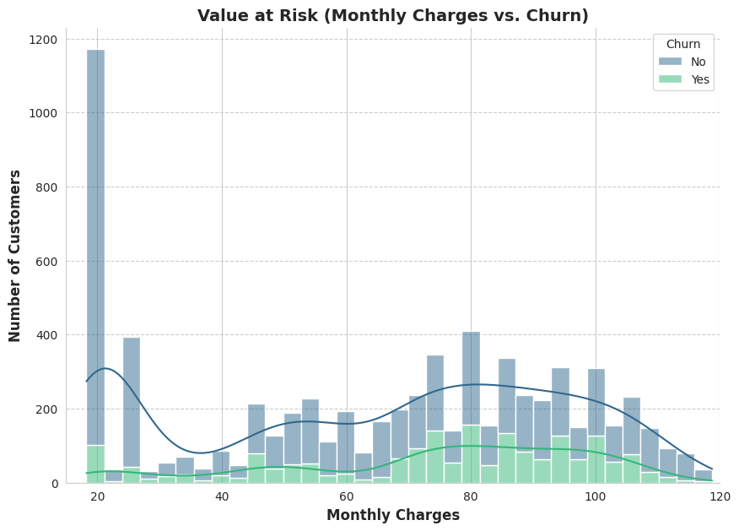
Finding: Customers with low monthly charges ($20–30) churn at 10.33%, while customers with high monthly charges ($75–120) churn at 34.67%.
Recommendation: Review whether premium plans deliver enough value, or bundle additional services to justify the higher price.

2.2 Follow-up — Is High Billing Churn Explained by Household Type or Add-Ons?
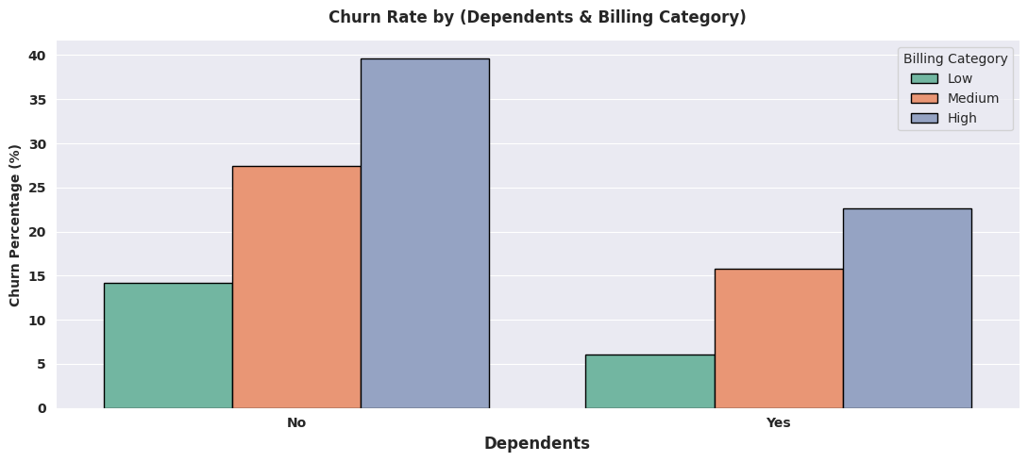
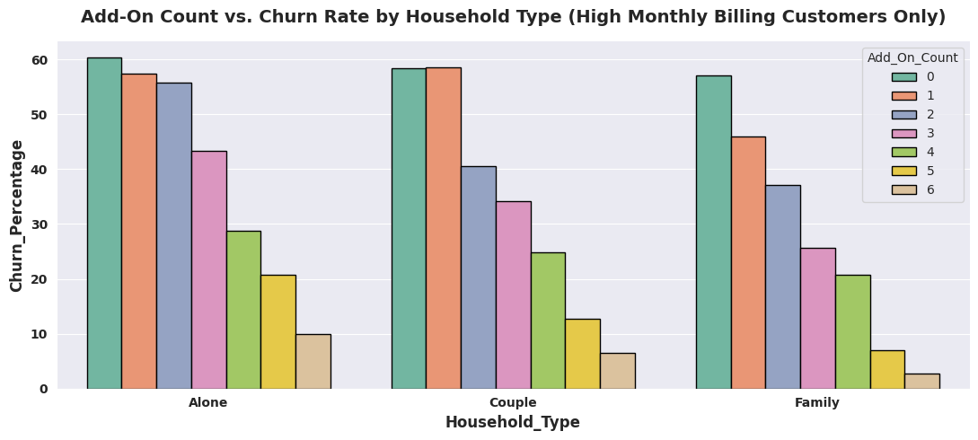
Finding: Among High-billing customers, churn drops sharply as the number of add-on services increases — from ~57–60% at 0 add-ons to ~3–10% at 6 add-ons — and this pattern holds consistently across all household types. Add-on count, not household type, is the real driver of churn risk in this group. (Add-On Count and Tenure showed a moderate positive correlation of 0.5, so this is read as a strong association rather than a fully independent cause.)
Recommendation: Offer discounted add-on bundles (e.g. Tech Support + Security) to High-billing customers with 0–2 add-ons, the segment with the steepest churn risk.

3. Does Contract Type Drive Churn?
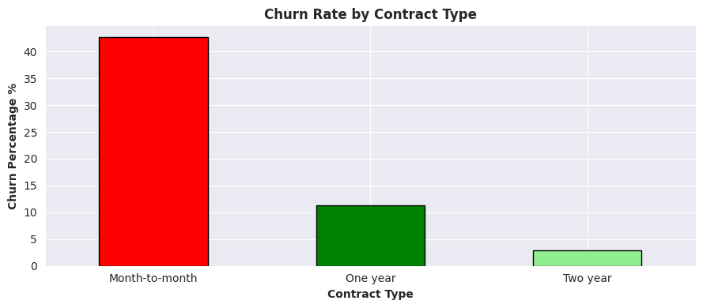
Finding: Month-to-month churn (~43%) is far higher than one-year (~11%) and two-year (~3%) contracts — the strongest single driver of churn found in this analysis.
Recommendation: Prioritize converting month-to-month customers to longer-term contracts through discounts or added perks.

3.1 Follow-up — Does Payment Method Add Risk on Top of Contract Type?
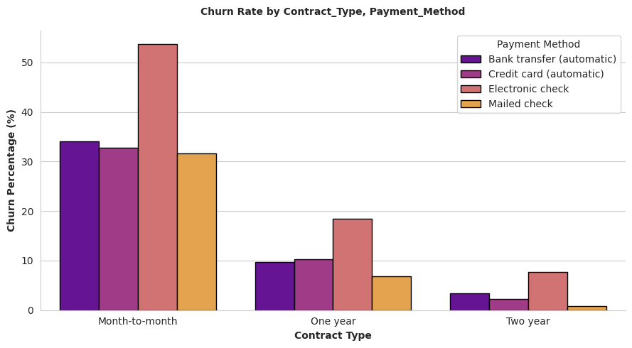
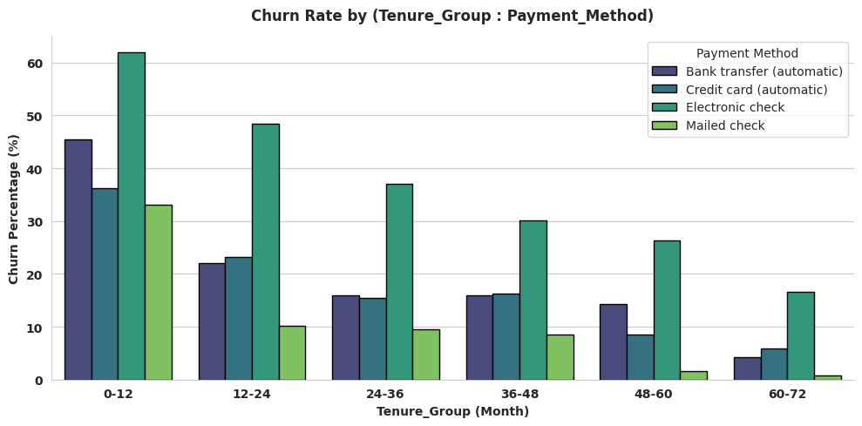
Finding: Electronic check has the highest churn rate within every contract type, and this holds true across every tenure range as well — confirming it's a genuine, independent risk factor, not just a result of those customers being newer.
Recommendation: Encourage Electronic check users to switch to automatic bank transfer or credit card payment, e.g. through a small switching incentive.

4. Does Internet Service Type Affect Churn?
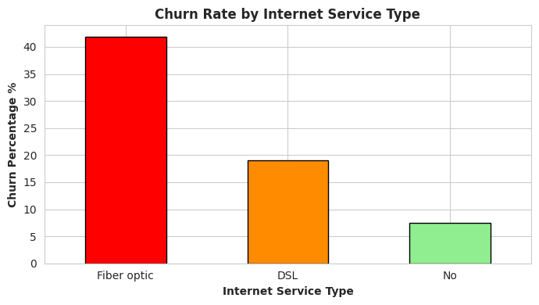
Finding: Fiber optic customers churn at 40%+, more than double DSL's ~20%, and far higher than customers with no internet service (~5%).

4.1 Follow-up — Is Fiber Optic's High Churn About the Product, or Missing Support?
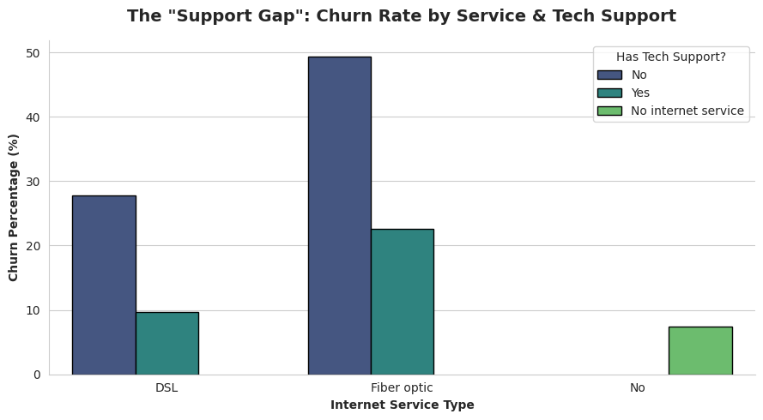
Finding: Within Fiber optic, customers without Tech Support churn at ~50%, versus ~23% with Tech Support — nearly double. The same pattern holds for DSL (28% vs 10%), but Fiber's gap is the largest.
Recommendation: Prioritize offering or bundling Tech Support for Fiber optic customers — the single largest churn-reduction opportunity found in this analysis.

4.2 Follow-up — Does Tech Support Matter More for Senior Citizens?
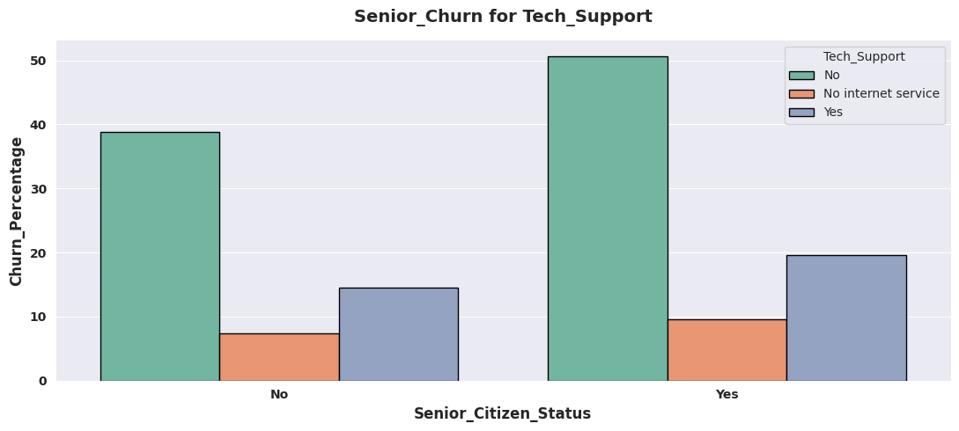
Finding: Senior Citizens churn more than non-seniors in every Tech Support category, but the gap is largest when Tech Support is missing (51% vs 39% — a 12-point gap), compared to only a 5-point gap when Tech Support is present.
Recommendation: When rolling out the Tech Support bundling recommendation, prioritize Senior Citizens first.

SQL Business Queries
The same analysis was reproduced and extended using SQL, to extract actionable customer lists directly usable by retention and marketing teams:
1. High-Risk Retention & Win-Back List — Month-to-month + Electronic Check
Extracts all customers on a Month-to-month contract paying via Electronic check (the highest-churn combination identified, ~53.7%), including current churn status — so the retention team can target still-active customers for prevention, while marketing builds a separate win-back list for those who already left.
2. Toxic Product Segment — Fiber Optic without Tech Support
Extracts all Fiber optic customers without Tech Support (~50% churn), the group most likely to benefit from a Tech Support bundling offer.
2.1 Priority Subset — Senior Citizens without Tech Support
Extracts all Senior Citizens without Tech Support (~51% churn, the largest gap of any group tested), so the company can prioritize this group when rolling out the Tech Support bundling recommendation.
3. Add-On Upsell Targets — High Billing, 0–2 Add-Ons
Extracts High-billing customers with 0–2 add-on services, the segment with the steepest churn risk, for the discounted bundle offer recommendation.
4. Cross-Check Aggregate — Churn Rate by Contract & Payment Method
Recreates the Contract × Payment Method churn analysis using SQL's GROUP BY, validating the same finding derived in Python and confirming it can be reproduced directly in SQL (Month-to-month + Electronic check confirmed at 53.73% churn, matching the Python result exactly).

Power BI Dashboard
The findings above were consolidated into an interactive three-page Power BI dashboard, so retention and marketing teams can explore churn risk by segment on their own instead of reading static charts. It answers two questions: which customers are most likely to leave, and what makes high-risk customers more likely to leave.
Executive Overview — headline KPIs (total customers, churn rate, revenue at risk, average tenure, average monthly charges) with churn rate by contract type, internet service, and payment method.
Deep Dive — churn rate by Contract × Payment Method, Household Type × Add-On Count, Fiber Optic × Tech Support, and Senior Citizen × Tech Support, with Household Type and Tech Support slicers synced across pages.
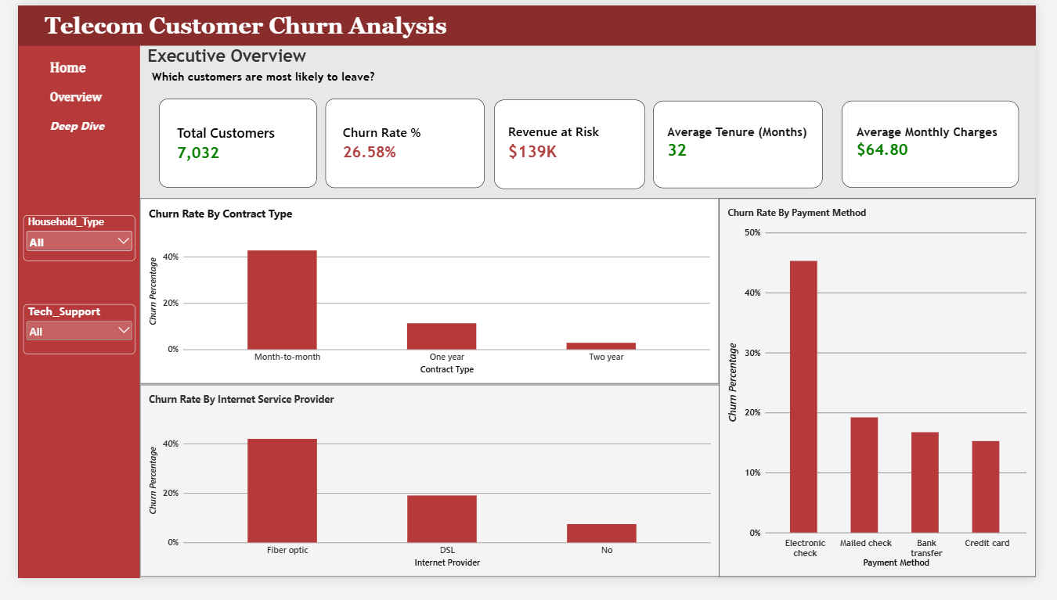
Executive Overview page
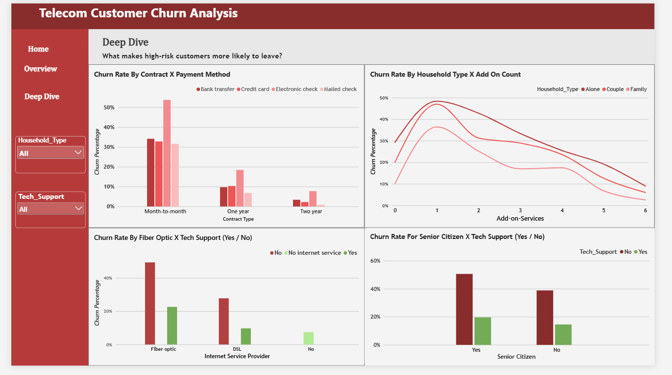
Deep Dive page

Overall Conclusion & Recommendations
This analysis identified several distinct, evidence-backed drivers of customer churn, each pointing to a specific, actionable lever for the company:
Finding: Contract type is the single strongest driver of churn — Month-to-month customers churn at ~43%, compared to ~3% for two-year contracts. Converting month-to-month customers to longer-term contracts should be the top priority.
Finding: Electronic check carries an independent churn risk, confirmed across every contract type and tenure range — encouraging a switch to automatic payment methods is a low-effort, broadly applicable lever.
Finding: Fiber optic customers without Tech Support are the highest-risk segment found in this analysis (~50% churn) — bundling or discounting Tech Support for this group offers the single largest churn-reduction opportunity, with Senior Citizens as the top priority within it.
Finding: High-billing customers with few add-ons show steep churn risk that drops sharply as add-on count increases — discounted bundles for this group are a clear upsell-and-retain opportunity.
Finding: New customers (0–5 months tenure) churn at the highest rate overall — a stronger onboarding experience in this window could reduce early losses across all other segments.
Together, these findings suggest the company's churn problem is not a single issue but a combination of contract structure, payment friction, and service support gaps — each addressable through a targeted, specific intervention rather than a single broad campaign.
Analysis by Debashis Sarkar

